# Question 1

## Question 1.3

**Visualization 1.3.1**

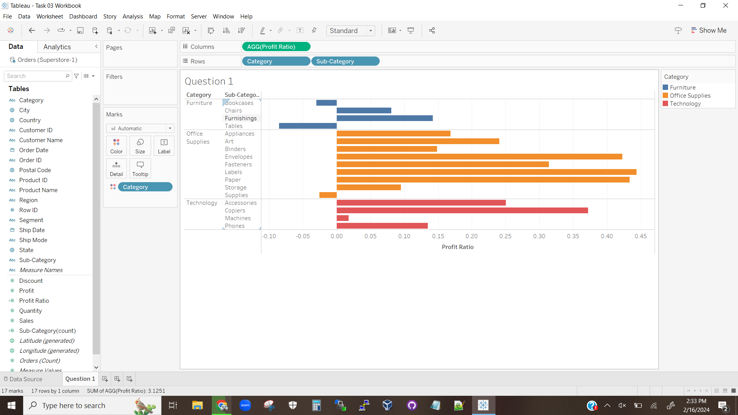

We can see from the above visualization that Office Supplies has the most high performing sub-categories as well as the highest performing sub-categories. Technology has fewer sub-categories to work with, but on average performs similarly up to and including one outlier of a very poor performing sub-category (Supplies for Office Supplies operates at a loss, while Technology’s Machines just as very low profit). While half of Furniture’s sub-categories have average profits, two of its sub-categories operate at a loss making Furniture a poor performing Category.

# Question 2

## Question 2.1

**Visualization 2.1.1**

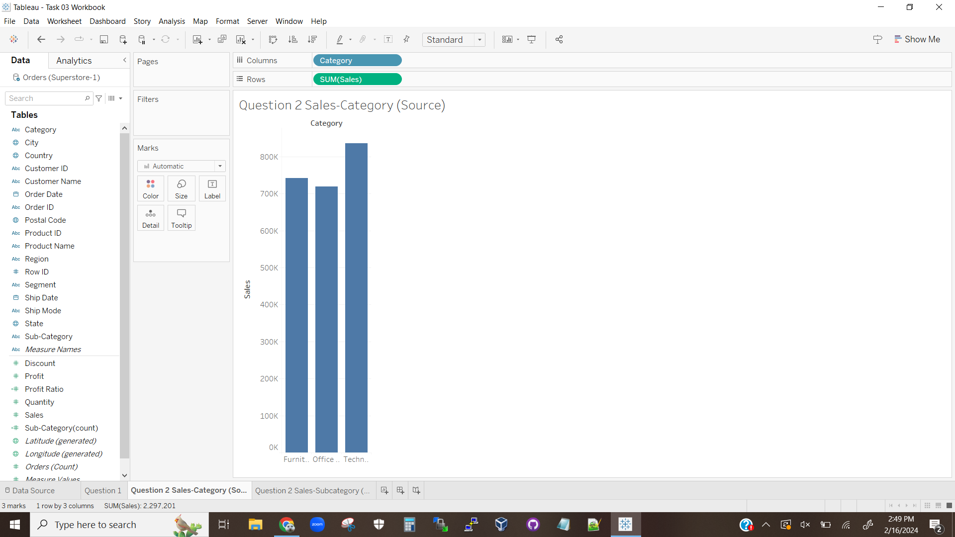

The above visualization displays the total sales per category.

## Question 2.2

**Visualization 2.2.1**

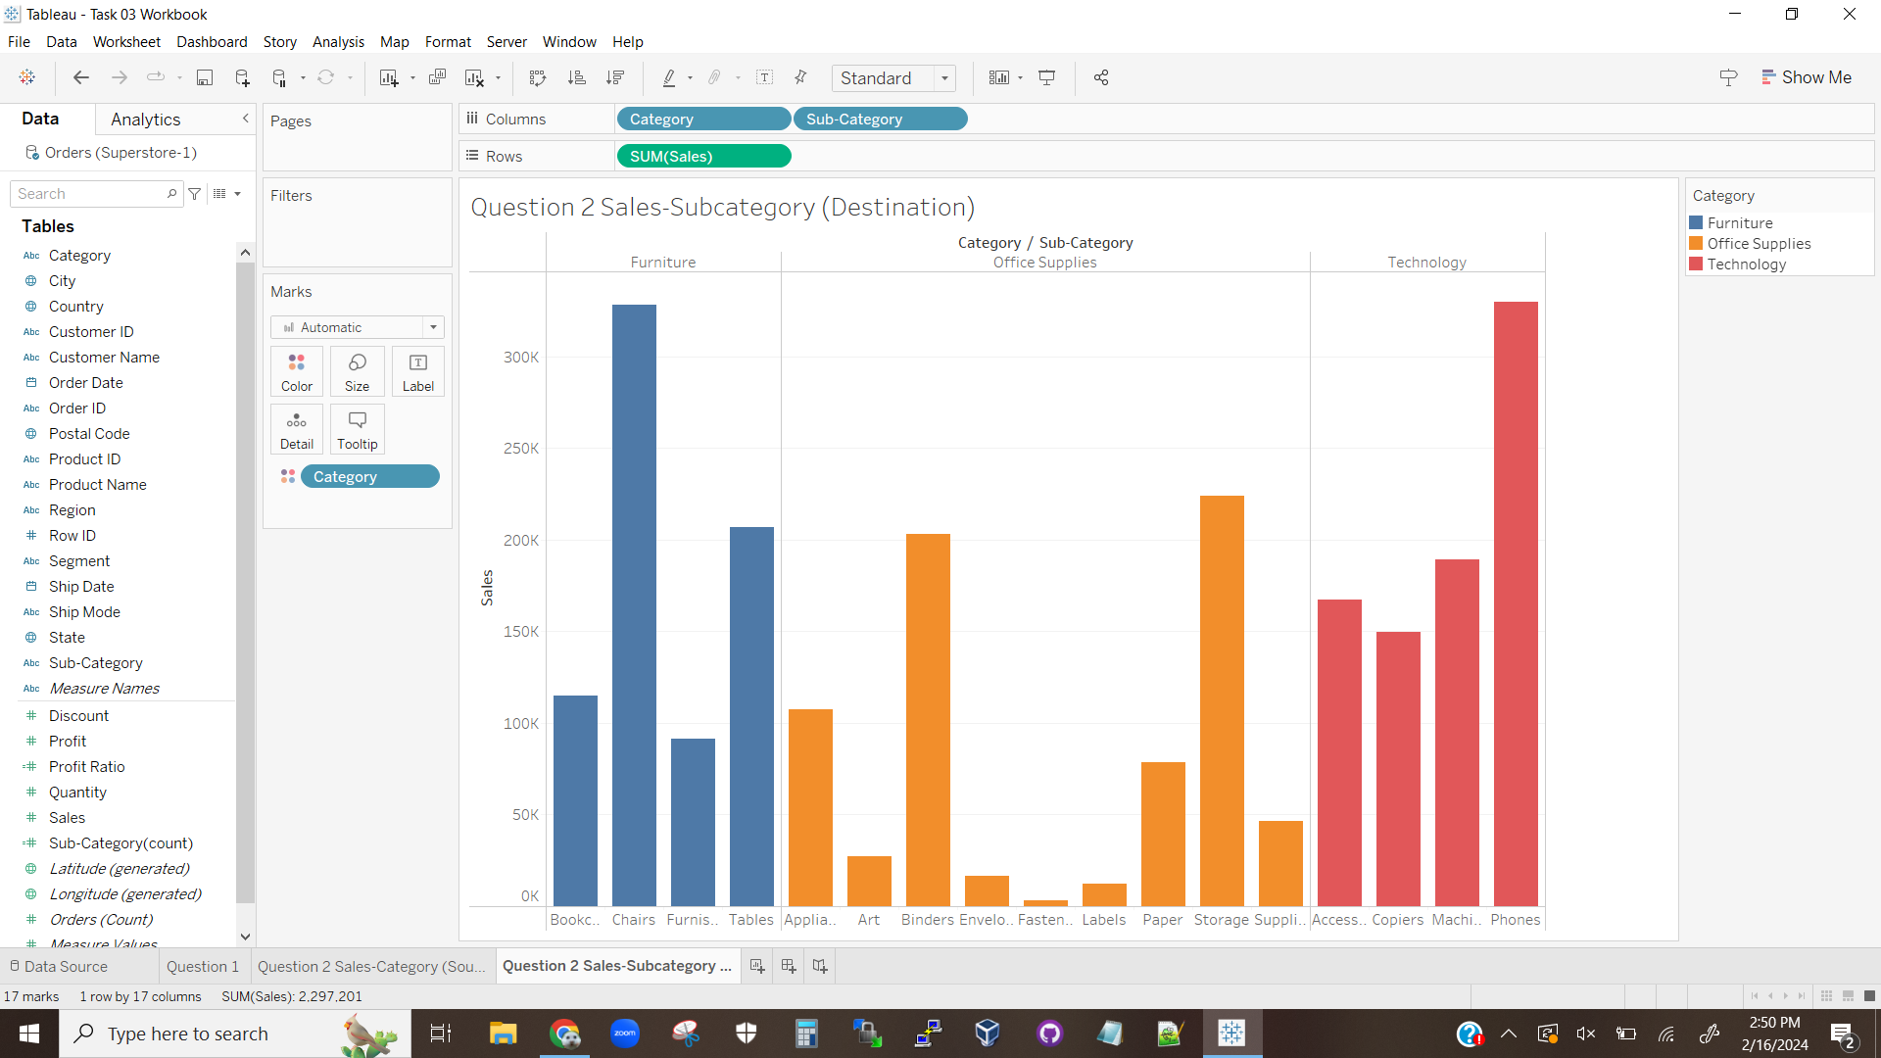

The above visualization displays the total sales for each Sub-Category, grouped by Category.

## Question 2.4

**Visualization 2.4.1**

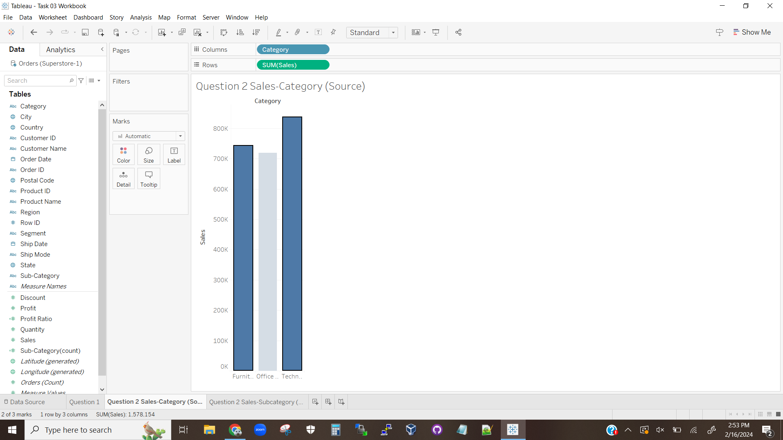

The above visualization shows how the source sheet, now linked to the destination sheet, has selected the Furniture and Technology Categories for filtering.

**Visualization 2.4.2**

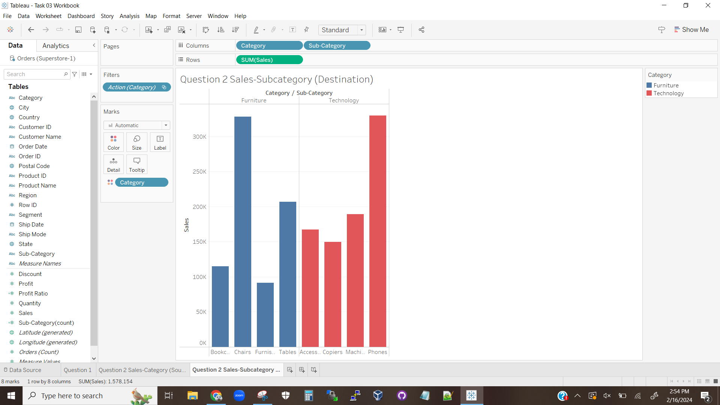

The above visualization shows how, based on the source sheet’s selections, the destination sheet’s viewable bars have been filtered.

# Question 3

## Question 3.1

**Visualization 3.1.1**

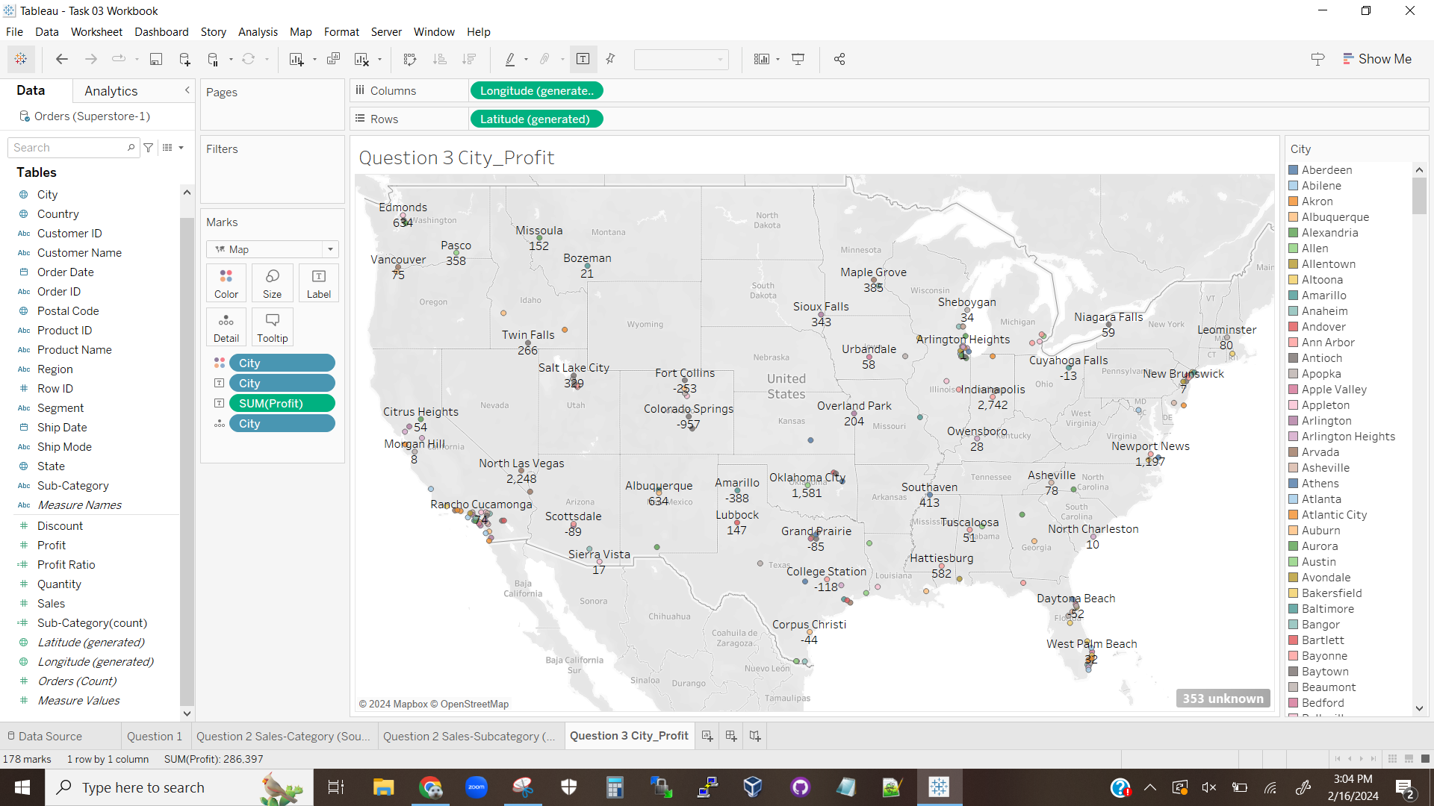

The above is a visualization showing a map where each dot represents a city, labeled by a unique color, the city’s name, and the profits for that city.

## Question 3.2

**Visualization 3.2.1**

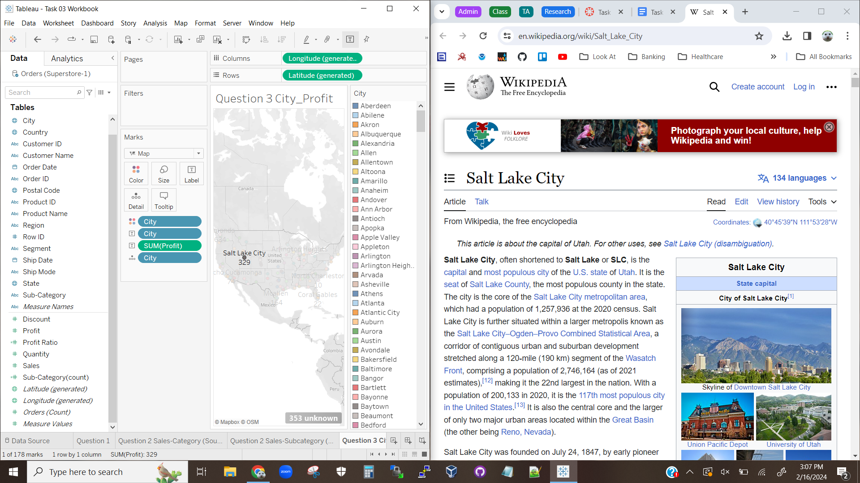

The above visualization shows how, after adding a hyperlink action, the Tableau sheet will route to a new browser tab for a city when clicked on. In this case, Salt Lake City, Ut, was selected.

## Question 3.3

**Visualization 3.3.1**



The above visualization shows Tableau routing to the Indianapolis Wikipedia page after being selected.

**Visualization 3.3.2**

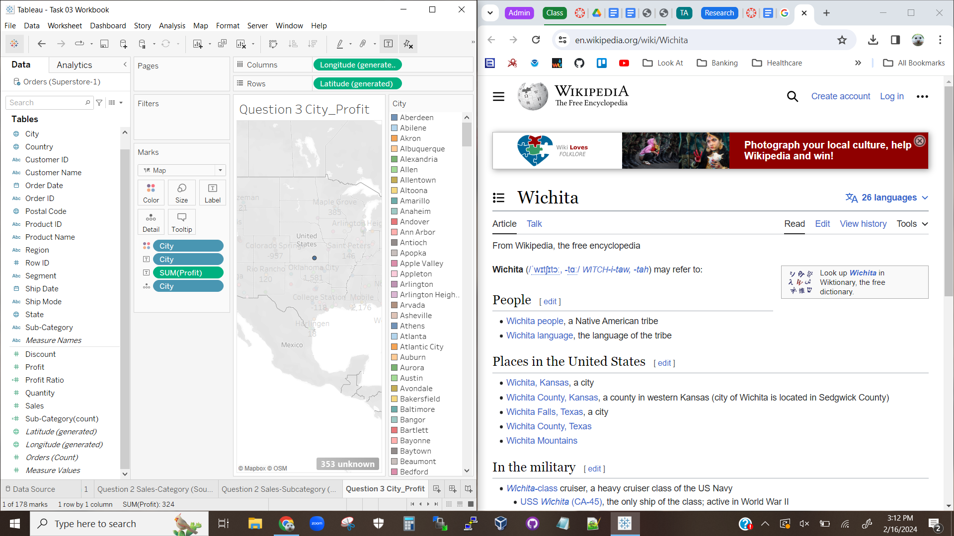

The above visualization shows Tableau trying to route to Wichita, Kansas’s Wikipedia page. However, since there are multiple pages with the name Wichita as all or part of the name, Tableau is routed to a disambiguation page since the hyperlink wasn’t more detailed.

## Question 3.4

The profit for Indianapolis is 2,742.

The profit for Wichita is 324.

# Question 4

## Question 4.3

**Visualization 4.3.1**

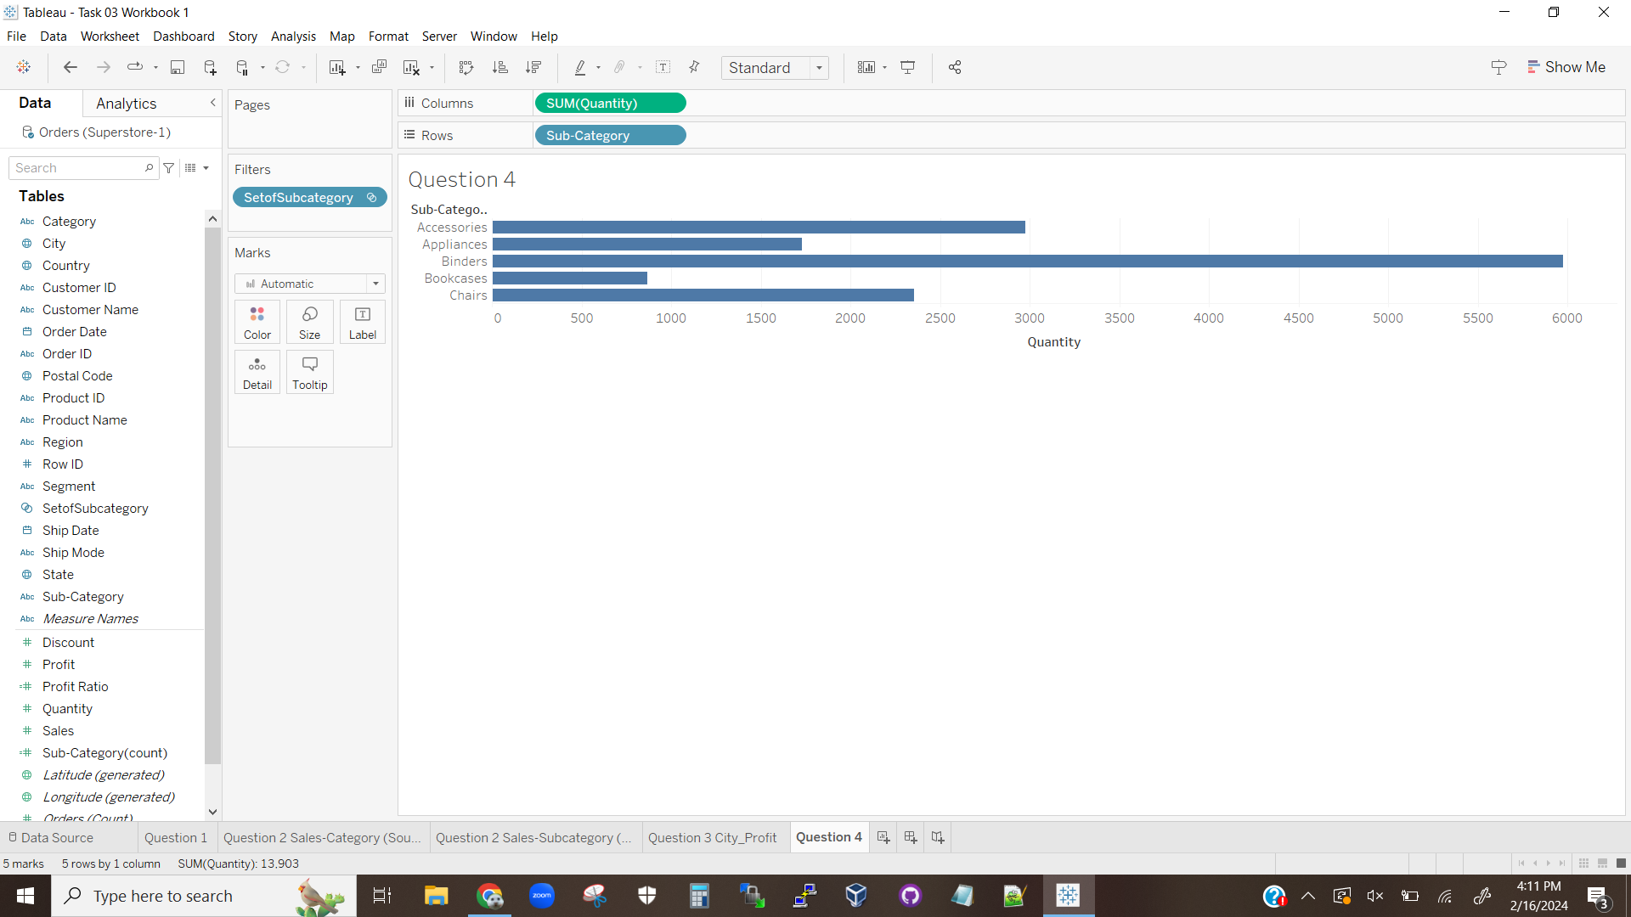

The above visualization shows the setup with filtering by a Sub-Category set.

## Question 4.5

**Visualization 4.5.1**

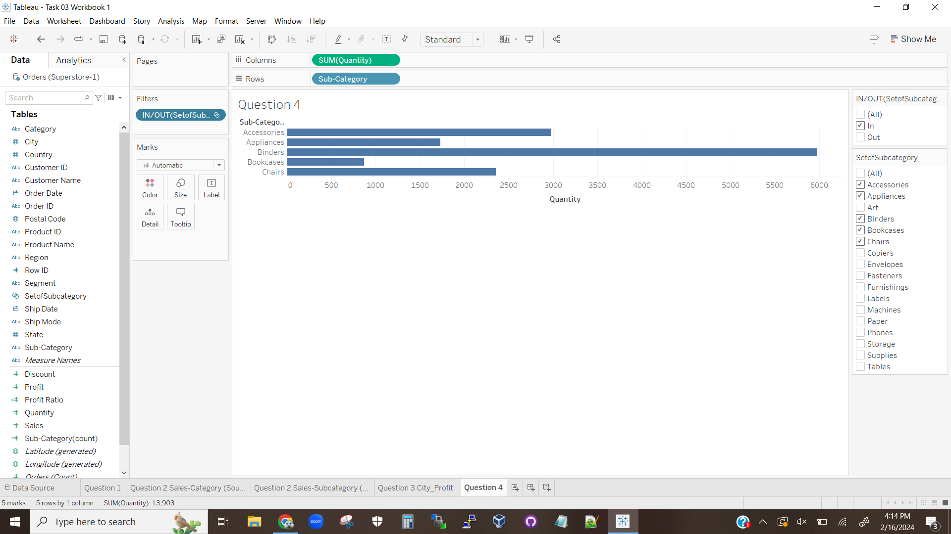

The above visualization shows the total quantities of items that are in Sub-Categories that are in the set. It is clearly shown that the Sub-Category Binders has sold over double the next best selling item, while Bookcases have sold just over half of the second-worst selling item.

**Visualization 4.5.2**

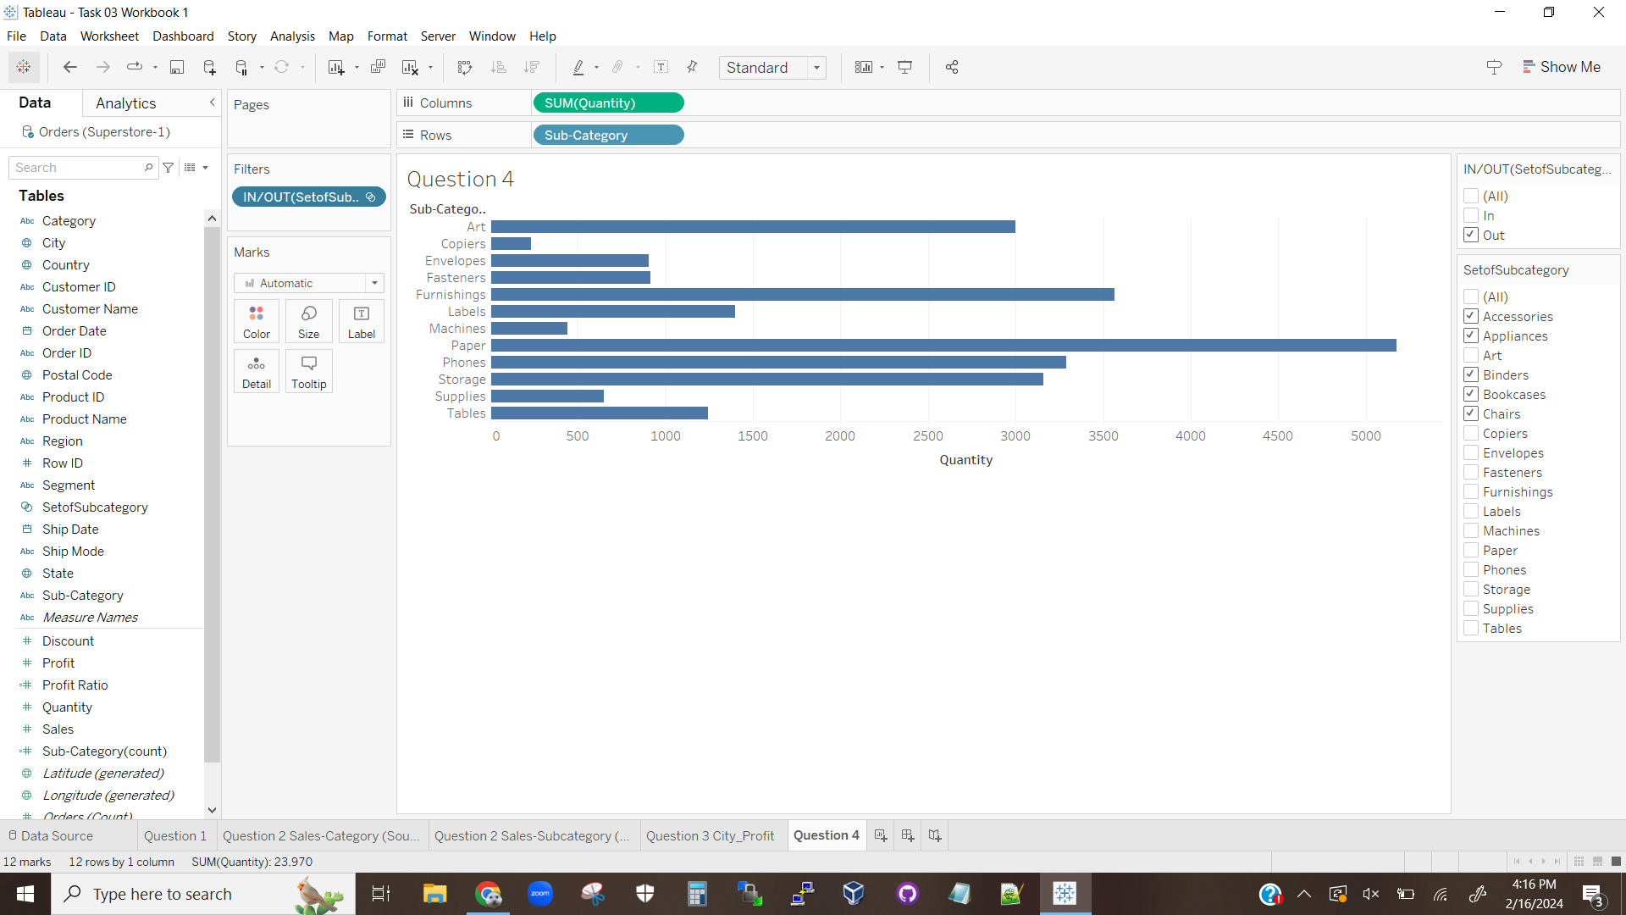

The above visualization shows the total quantities of items that are in Sub-Categories that are not in the set. No one category sold massively better like in Sub-Categories in the set, but by value paper clearly sold almost as well as binders did. Copiers sold terribly, with sales being a little over half of the next worst-selling item. Copiers also sold much worse than Bookcases from the in-set Sub-Categories, making it the overall worst-selling item.

# Question 5

## Question 5.2

**Visualization 5.2.1**



The above visualization shows that the Category (group) field has been created.

## Question 5.4

**Visualization 5.4.1**

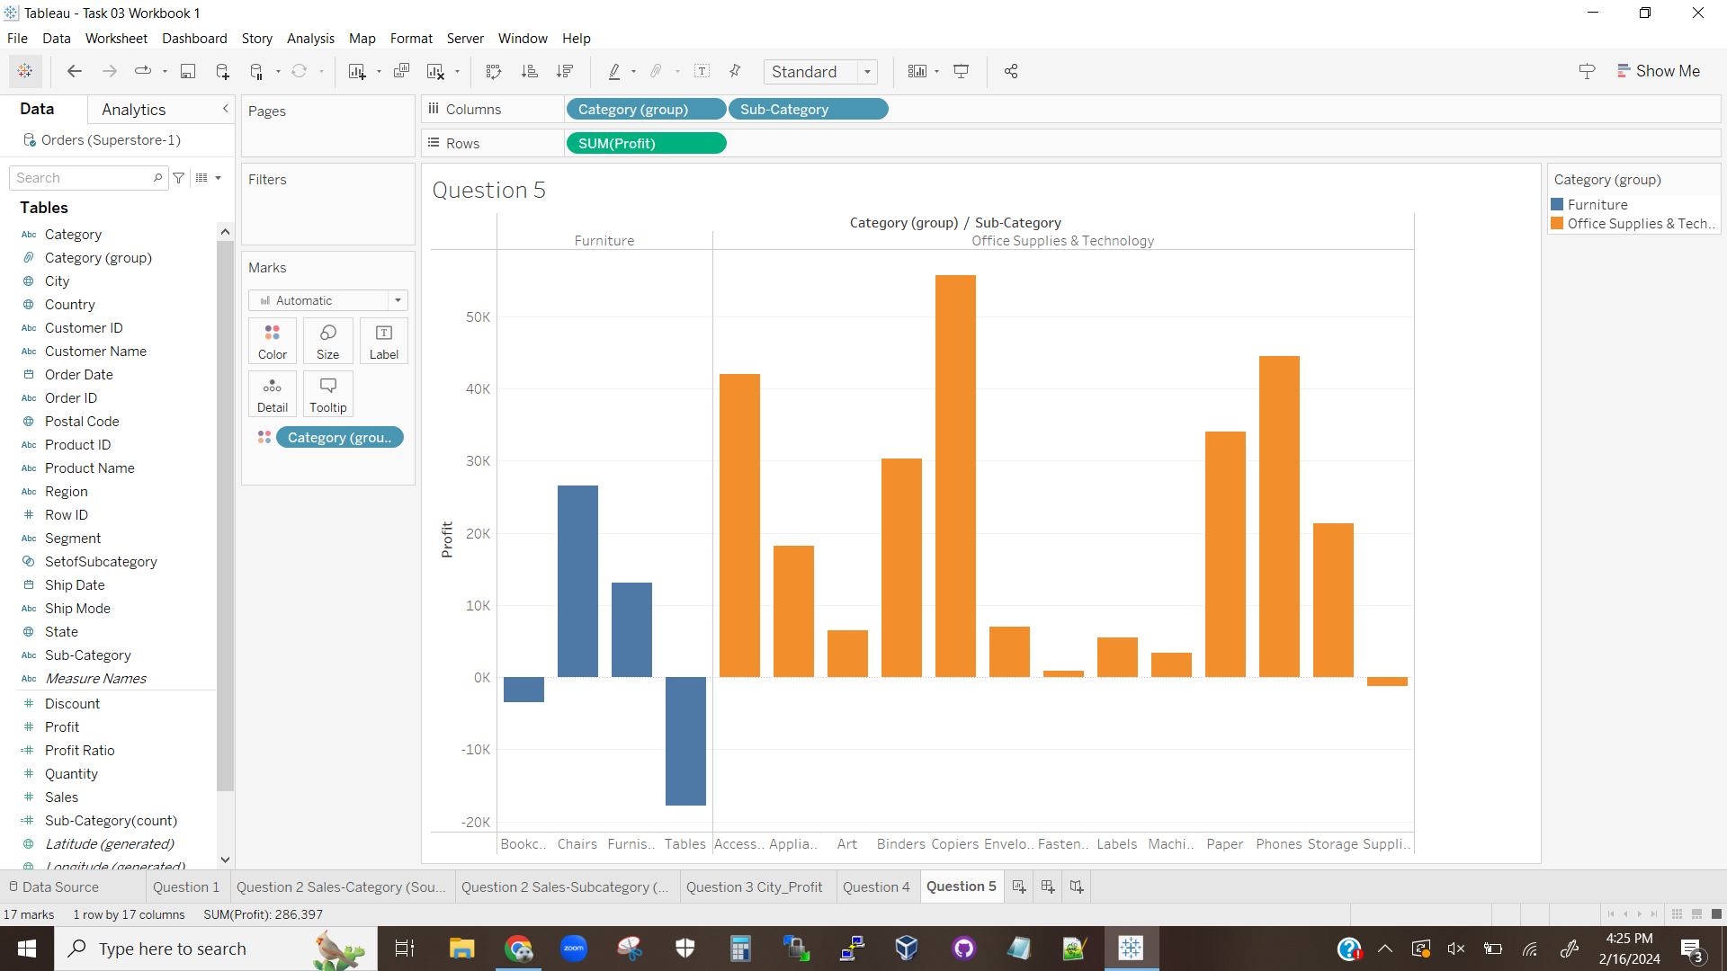

The above visualization shows a histogram of the data. We can clearly see that the Sub-Categories in the group have the higher variability than those that don’t. The Sub-Categories in the group also contain the highest performers, and only contain one Sub-Category operating at a loss. Furniture, on the other hand, has half of its Sub-Categories performing moderately well while the other two operate at a loss with Tables in particular costing a lot of money. Overall Furniture is not a highly profitable Category for this company, unlike the other two Categories.

**Visualization 5.4.2**

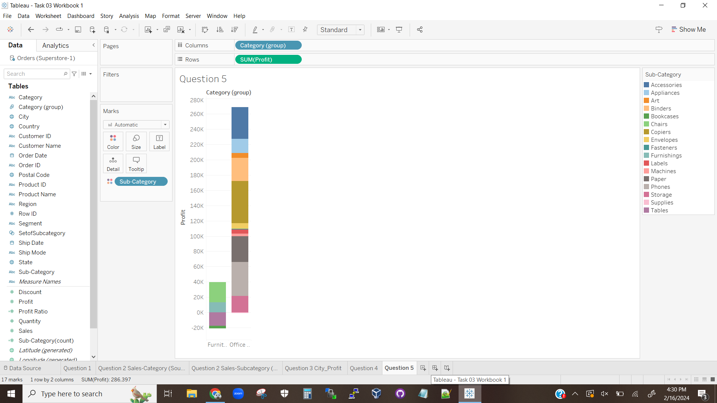

The above visualization shows that the Sub-Categories in the group combined massively outperform those in Furniture. Additionally, while one Sub-Category in the group operates at a loss, that loss is minor and the rest of the sub-categories more than make up for it. Furniture, on the other hand, operates at a significant loss and loses about half of its profits to the losses in its two worst sub-categories.